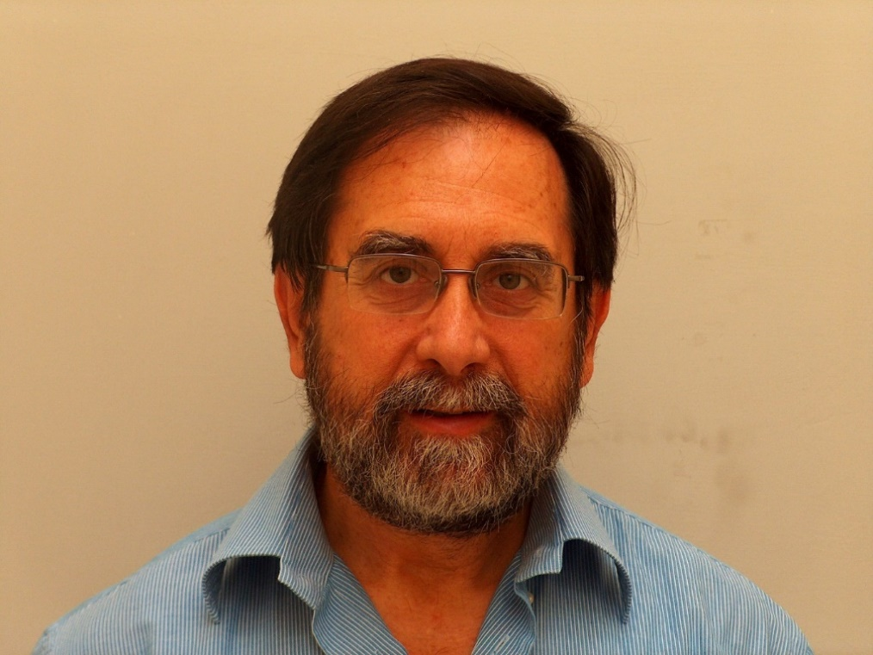

Marcello Nicoletti

Nationality – Italy

Born in Rome Date: 23.07.1950

Address – Dept. of Environmental Biology

University Sapienza of Rome

P.le A. Moro 5 00185 Rome, Italy

Email : [marcello.nicoletti@uniroma1](mailto:marcello.nicoletti@uniroma1). It

Tel. : 00390649912195

Mobile : 00394346999

**An alternative Curriculum Vitae with personal remarks**

*Two or thee things that I learned during my life*

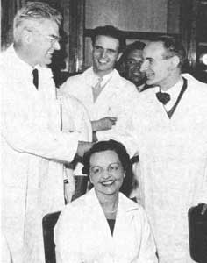

Prof. Marini-Bettolo (on the left) with the Nobel Prize Daniel Bovet (on the right)

At the age of eighteen, I lost my father, which was the only one in the family with a salary. My family was a medium class one and therefore I had to face the new situation, as the major of three sons. Fortunately, I was able to obtain a grant to continue my study and enter at university Sapienza of Rome. I had to hurry and in 1974 I was able obtain the degree in Chemistry in the minimum time with the maximum cum laude. Later, I obtained another degree in Industrial Chemistry.

At the University, I found another father in professor Marini-Bettolo, which was fundamental in my formation, in any sense. The professor was at the time the president of the Accademia dei XL, the most important academic institution in Italy, and of the Pontifica Accademica of Sciences, in Vaticano, beside to be the director of a Center for Natural Products of the National Research Country. His merit was not limited to the scientific ones. Because of his position in the neutral Vaticano, he was fundamental in the dialog between the two blocks after the second World War. He was able to obtain meetings between USA and URSS, first at the scientists level and later at most important political one against the nuclear armament. At that time, the human race was near to destroy himself.

I still have the photos of first page of Pravda with my professor facing Breznew. He was fundamental in the freedom of Sacharow. The name of Marini-Bettolo is not present in the books of history, but I know that probably the present world could be different without his presence and personal effort.

For some reasons, prof. Marini-Bettolo imagined some importance in that very young and confused student, like I was, and decided to help me. First, he sent me at Cambridge, UK, for the postdoctoral formation under the direction of Sir Alan Battersby. At that time, the Chemical Laboratories on Lansfield Road were probably one of the best school of Organic Chemistry. In Cambridge I was able to complete my research that was sufficient for the PhD title, but I had no possibility to pay the taxes.

Prof. Marini-Bettolo was a pioneer in the study of medicinal plants, when everybody was involved in synthetic pharmaceutic chemistry. He introduced me in the research on secondary metabolites and their millenarian importance for humanity. All my basic knowledge and the development of my subsequent work derived directly from his training and without this imprinting, all my further steps would be wasting time. Prof. Marini-Bettolo had an enormous influence in South America and decided to use me sending me in several countries to take his heritage. After Cambridge, I travelled through South America, first two years in Brazil, and later Mexico, Chile and many others. The idea was to study the chemical contents of medicinal plants starting from the knowledge of the local traditional medicine. I had to travel for studying the medicinal plants of many countries, from the curare of the Indios of Amazonia to the endemic plants of the dessert of Chile. At that time, in Organic Chemistry, everybody was interested to the magical bullet that could have a therapeutic interest for the pharmaceutical industry and to the synthetic approach. On the contrary, prof. Marini-Bettolo was interested in natural products and transferred this interest to me. Therefore, I was a pioneer, in every sense.

The scientific results were very interesting and my academic career very rapid. In few years, I became full professor at the University Sapienza of Rome. Meanwhile, the interest on herbal remedies was started and the pharmaceutical product was began to change. However, I was not really satisfied. The possibility to reach the ordinary people with the results of my research was very low. I was looking to the enormous quantity of papers published, asking me the real value of all this production.

Practically in that moment, someone appeared at the door of my laboratory. The vicepresident of the Ferrero industry (the producer of Nutella) asked me to collaborate to a new product to produce and market. During the years of collaboration with Ferrero, I learned a lot about the concept of functional food and the role of technology in development of modern form of nutrition, as well as the possibility to use a plant for different purposes. Important was the relationship with the boss of Ferrero, mister Michele, recently deceased.

The study of neem was the real possibility to experiment the new deal of natural products, concerning the multifunctionality approach for a medicinal plant, giving rise to a possible plethora of marketed products. Today, I fill at the beginning of a new possible world starting from the crack

of the old models. With me, a plethora of researchers also attracted by the neem properties and a series of industries interested in production of innovative products.

As always, technological utilization of natural sources, including natural products, is the key for the future of the planet and Science is asked to play its role in the right direction.