First Author*, Second Author°

TITLE

Abstract. Write here the abstract. 150-200 words.

Keywords: first keyword, second keyword, third keyword.

- First paragraph

Write here the first paragraph. Subheadings must be 11 pt, bold, ranged left, with two line spaces (11pt) above and one beneath (11 pt), no indent, and numbered consecutively 1., 2. The initial word of the subheading is in upper-case.
Main text: 11 pt, with an indent of 0.5 in the first line

  - Lower order paragraph

Formulas: centred, one line (11 pt) spacing below the text and one line (11 pt) space below the formula with consecutive numbering on the right.

y_{it}=βx’_{it}+α_{i}+ε_{it} (1)

    - Sub-lower order paragraph

Tables and figures may be submitted in all major graphic file formats (300 dpi). They must be inserted in the text and also submitted in a separate file.

Table 1. Variability decomposition, in terms of standard deviations
 | Overall | Between | Within
GDP per capita | 4.57 | 2.02 | 4.13
Investment (% of GDP) | 9.70 | 8.46 | 5.45
Mean years of schooling | 1.49 | 1.44 | 0.55
Public expenditure (% of GDP) GDP ratio | 5.90 | 4.05 | 4.03
Public revenue as GDP ratio | 5.58 | 5.43 | 1.73
Population growth | 0.94 | 0.82 | 0.52
Source: Our elaborations on Eurostat data

Figure 1. Relative percent change in gross and domestic VA exports of goods and services in European countries (1995-2008)
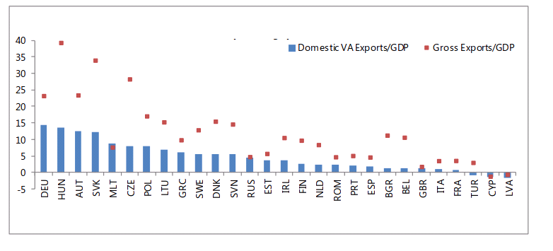Source: IMF (2013)

References are listed alphabetically at the end of the article. Start with the title References (11 pt, bold) with two lines space (11 pt) below the text and one line space (11 pt) before the list of references. The second line of each reference is indented 0.5.

References

AGENZIA DELLE ENTRATE (2010), Più operative e disegnate sul tuo profilo, Press Release, 26 October, available at www.agenziaentrate.gov.it [29 October, 2018]
BARRO R. J. (1990), Government Spending in a Simple Model of Endogenous Growth, Journal of Political Economy, 98(5), 103-26.
DOSI G., NAPOLETANO M., ROVENTINI A., TREIBICH T. (2014), The Short- and Long-Run Damages of Fiscal Austerity: Keynes beyond Schumpeter, in STIGLITZ J.E., GUZMAN M. (eds.), Contemporary Issues in Macroeconomics. International Economic Association Series. Palgrave Macmillan, London.
EUROSTAT (2013), European System of Accounts – ESA 2010, European Commission.

* First author affiliation ° Second author affiliation

