Titolo progetto:_____________________________________

Settore di attività:____________________________________

Componenti team progetto:____________________________

1 -Riepilogo delle Previsioni economiche della iniziativa:

 | 1° Esercizio | 2° Esercizio | 3° Esercizio
- Fatturato
- Investimenti
- Costi di gestione

2- Numero dei dipendenti attualmente in forza e/o che si prevede di utilizzare nei periodi considerati al punto precedente.

Breve descrizione
______________________________________________________________________________________________________________________________________________________________________________________________________________________________________________________________________________________________________________________________________________________________________________________________________________________________________________________________________________________________________________________________________________________________________________________________________________________________________________________

3- Principali rapporti commerciali e finanziari previsti per l'iniziativa (clienti, fornitori, banche):

Breve descrizione
________________________________________________________________________________________________________________________________________________________________________________________________________________________________________________________________________________________________________________________________________________________________________________________________________________________________________________________________________________________________________________________

4 - Programma degli investimenti :

a) Descrizione dell'investimento (vedi relazione allegata)
b) Sintesi dell'investimento e del costo .

Voci di spesa | 1° Esercizio | 2° Esercizio | 3° Esercizio
°Immobili
°Ristrutturazioni
°Macchinari
°Attrezzature
°Automezzi
°Brevetti /
Programmi
Totale

c) Piano finanziario di copertura

 | 1° Esercizio | 2° Esercizio | 3° Esercizio
°Mezzi propri
°Nuovi apporti di capitale
°Prestiti da soci
°Finanziam. pubblici
Totale

Spese già compiute alla data di presentazione della domanda Euro:
Tempi di attuazione del programma di investimento:

- Inizio: Fine:

Firma
Legale Rappresentante.

PARTE PRIMA
Sommario esecutivo

Struttura societaria

Fondatori Attività attuali Quote
(Informazioni su Soci)
Socio A
____________________________________________________________________________________________________________________________________________________________________________________________________________________________________________________________

Socio B
____________________________________________________________________________________________________________________________________________________________________________________________________________________________________________________________

Socio C
____________________________________________________________________________________________________________________________________________________________________________________________________________________________________________________________

ecc
________________________________________________________________________________________________________________________________

Tipo di Società Motivazioni

S.r.l.
S.a.s.
S.n.c.
Ditta Individuale
Cooperativa
Piccola Cooperativa

Business Motivazioni al business

Definizione dell'area di business in cui l'azienda
intende operare (produzione, commercio, servizi,ecc)
___________________________________________________________________________________________________________________________________________________________________________________________________________________________________________________________________________________________________________________________

BUSINESS IDEA
Settore Produttivo
e/o Servizio Offerto
________________________________________________________________________________________________________________________________________________________________________________________________________________________________________________________________________________________________________________________________________________________________________________________________________________________________________________________________________________________________________________________

Posizionamento
nel settore di intervento
___________________________________________________________________________________________________________________________________________________________________________________________________________________________________________________________________________________________________________________________

Concorrenza

Strategie prezzi

Collegamento tra la business idea proposta e le finalità del Progetto UPPER, con particolare riferimento alle Nature Based Solution (NBSs)

________________________________________________________________________________________________________________________________________________________________________________________________________________________________________________________________________________________________________________________________________________________________________________________________________________________________________________________________________________________________________________________

Schema per la descrizione del Business Model

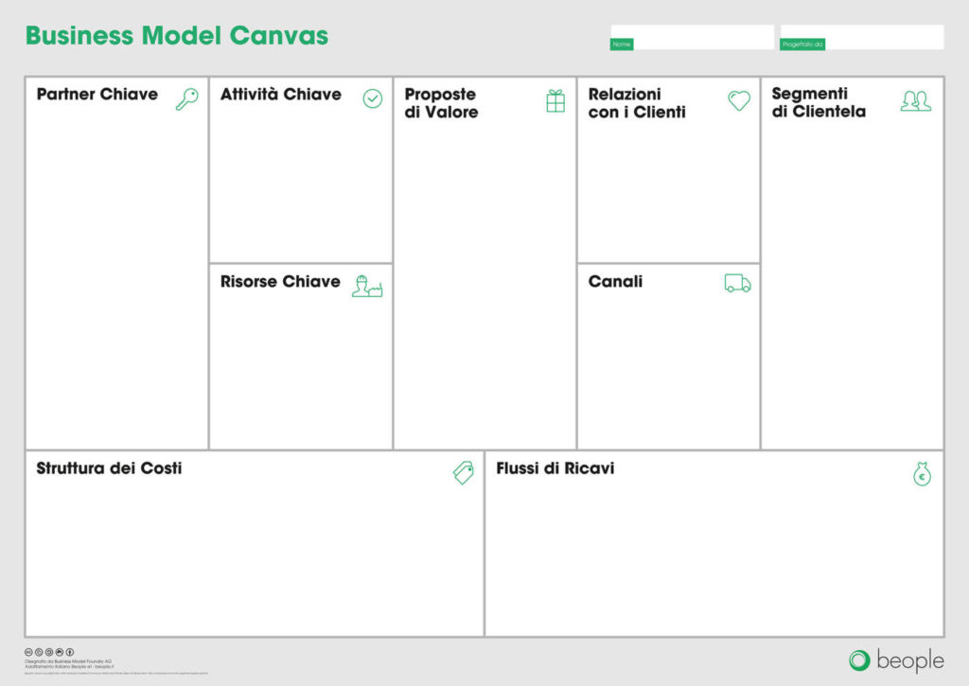

Focus: schema per dettagliare la Sez. “Proposta di valore” del Business Model

Stakeholder | Aree dell’impatto economico-sociale della business idea (es. benessere, salute psico-fisica, equità sociale; creazione di green jobs; inclusività sociale ecc.)
cittadini
scuole e università
pubblica amministrazione
imprese (se occorre, specificare per settore di appartenenza: es. imprese culturali, agroalimentari, alberghiere, terzo settore ecc.)

PARTE SECONDA

La struttura giuridica, il prodotto, i mercati

La Storia dell'azienda

Il passato
_______________________________________________________________________________________________________________________________________________________________________________________________________________________________________________________________________________________________________________________________________________________________________________________________________________________________________________________________________________________________________________________________________________________________________________________

- Il presente
_______________________________________________________________________________________________________________________________________________________________________________________________________________________________________________________________________________________________________________________________________________________________________________________________________________________________________________________________________________________________________________________________________________________________________________________

- Il futuro
_______________________________________________________________________________________________________________________________________________________________________________________________________________________________________________________________________________________________________________________________________________________________________________________________________________________________________________________________________________________________________________________________________________________________________________________

La Struttura organizzativa

I CURRICULUM
(dettagliati curriculum scolastici/lavoro)
_______________________________________________________________________________________________________________________________________________________________________________________________________________________________________________________________________________________________________________________________________________________________________________________________________________________________________________________________________________________________________________________________________________________________________________________

MANSIONI
(che assumeranno nella nuova iniziativa)
_______________________________________________________________________________________________________________________________________________________________________________________________________________________________________________________________________________________________________________________________________________________________________________________________________________________________________________________________________________________________________________________________________________________________________________________

OBIETTIVI E STRATEGIA

- Obiettivi e strategia
________________________________________________________________________________________________________________________________________________________________________________________________________________________________________________________________________________________________________________________________________________________________________________________________________________________________________________________________________________________________________________________

- Il Mercato
__________________________________________________________________________________________________________________________________________________________________________________________________________________________________________________________________________________________________________________________________________________________________________________________

- La Concorrenza
____________________________________________________________________________________________________________________________________________________________________________________________________________________________________________________________________________________________________________________________________________________________________________________________________________________________________________________________________________________________________________________________________________________________________________________________________________________________________________________________________________________________________________________________________________________________________________________

- Promozione e pubblicità
__________________________________________________________________________________________________________________________________________________________________________________________________________________________________________________________________________________________________________________________________________________________________________________________

- Il piano di Marketing

_____________________________________________________________________________________________________________________________________________________________________________________________

